THE FEDERAL UNIVERSITY OF TECHNOLOGY, AKURE

SCHOOL OF ENGINEERING AND ENGINEERING TECHNOLOGY

A REPORT ON

NUMERICAL DETERMINATION OF FLUID (R134A) FLOW RATE IN PIPES USING A VENTURIMETER

COMPILED BY

MEE GROUP 4

SUBMITTED TO:

Dr T.S. MOGAJI

DEPARTMENT OF MECHANICAL ENGINEERING

COURSE: APPLIED FLUID MECHANICS (MEE 307)

|  |  |  |
| --- | --- | --- |
| S/N | NAME | MATRIC NO |
| 1 | AKINYEMI FAVOUR OLUWATOYIN | MEE/16/7962 |
| 2 | ALAYO FORTUNE AYOMIDE | MEE/16/7963 |
| 3 | ALIU JOLADE KHALIDAH | MEE/16/7964 |
| 4 | AMEEN IBRAHIM MAYODE | MEE/16/7965 |
| 5 | AMEJI OJOCHIDE | MEE/16/7966 |
| 6 | AYANDIPE TIMOTHY FAITH | MEE/16/7970 |
| 7 | AYANO JOSEPH OLUWAMAYOWA | MEE/16/7971 |
| 8 | AYENI DANIEL OLAOLUWA | MEE/16/7972 |
| 9 | AYORINDE OLANREWAJU | MEE/16/7973 |

JULY, 2019

Table of Contents

ABSTRACT 3

INTRODUCTION 4

1.1 Fluid Mechanism 4

• **Fluid dynamics** 4

Thisis a subdivision of fluid mechanics that deals with fluidflowi.e. the science of liquids and gases in motion. The solution to a fluid dynamics problem typically involves calculating various properties of the fluid, such as velocity, pressure, density, and temperature, as functions of space and time 4

1.2 Fluid Flow 4

1.3 Measurement of Fluid flow 4

1.3.1 Venturimeter 5

1.3.2 Orifice Meter 5

1.4 APPLICATION OF VENTURI METER AND ORIFICE METER 6

1.5 Fluid to be considered: R134A (1,1,1,2-Tetrafluoroethane) 6

1.5.1 PROPERTIES OF R134A 7

1.5.2 USES OF R134A (1,1,1,2-Tetrafluoroethane) 7

LITERATURE REVIEW 8

METHODOLOGY OF ANALYSIS 10

3.1 Mathematical/Analytical solution of the given problem 10

RESULTS AND DISCUSSION 12

DISCUSSION 12

Table and Graph of flow rate against the throat diameter 12

4.1.2. A Graphical User Interface (GUI) Python Code for validation of the analytical solution 13

Resut of calculation Program 19

FLOWCHART OF PROGRAM 20

CONCLUSION 23

REERENCES 25

# ABSTRACT

This work focuses on the numerical experimentation of flow rates of fluid. It involves using a software (a programming language) in designing a user interface for determining the rate at which a particular fluid flows in any flow measuring instruments. This document aims to describe how it is achieved in the five chapters to be discussed below. The first chapter discusses the concepts of fluid and its flow and also identifies the various classifications of fluid measuring instruments (***flow meters***) and their applications. The second chapter reveals the various works of indivduals who had contributed to the concept of fluid flow and its measurement by reviewing their publications. The third chapter explains the methods used in order to enhance the achievement of the analysis ranging from the governing equations and formulae used and mathematical solution of the given problem. The Fourth chapter shows the validation with Python Programming Language. It further shows the changes in the flow rate when there are variations in the throat diameter of the venturi meter. The last chapter therefore concludes that the flow rate of any fluid in flow measuring instruments can not only be determined analytically or mathematically in black and white but can also be validated or determined through computer programming languages.

# INTRODUCTION

## 1.1 Fluid Mechanism

Fluid Mechanics can be defined as the science which deals with the study of behaviour of fluids either at rest or in motion.It can be divided into [fluid statics](https://en.wikipedia.org/wiki/Fluid_statics)and [fluid dynamics](https://en.wikipedia.org/wiki/Fluid_dynamics).

* **Fluid static**

It is the branch of fluid mechanics that studies fluids at rest. It deals with the study of the conditions under which fluids are at rest in stable equilibrium and is contrasted with fluid dynamics, the study of fluids in motion. Fluid statics is fundamental to [hydraulics](https://en.wikipedia.org/wiki/Hydraulics), the [engineering](https://en.wikipedia.org/wiki/Engineering) of equipment for storing, transporting and using fluids.

* **Fluid dynamics**

Thisis a subdivision of fluid mechanics that deals with fluidflowi.e. the science of liquids and gases in motion. The solution to a fluid dynamics problem typically involves calculating various properties of the fluid, such as [velocity](https://en.wikipedia.org/wiki/Velocity), [pressure](https://en.wikipedia.org/wiki/Pressure), [density](https://en.wikipedia.org/wiki/Density), and [temperature](https://en.wikipedia.org/wiki/Temperature), as functions of space and time

## 1.2 Fluid Flow

Fluid Flow is a part of fluid mechanics and deals with fluid dynamics. Fluids such as gases and liquids in motion are called as fluid flow. Motion of a fluid subjected to unbalanced forces. This motion continues as long as unbalanced forces are applied.

## 1.3 Measurement of Fluid flow

Venturimeter and orifice meter are the commonly used flow meters for measuring mass/volumetric flow rate or velocity of the flowing fluid.

### 1.3.1 Venturimeter

The venturimeter has a converging conical inlet, a cylindrical throat and a diverging recovery cone. It has no projections into the fluid, no sharp corners and no sudden changes in contour. The figure below shows the venturimeter with uniform cylindrical section before converging entrance, a throat and divergent outlet.

The venturimeter has 3 main parts as shown in figure 1 below

1. **Short converging part:** It is a tapered portion whose radius decreases as we move forward.
2. **Throat:** It is middle portion of the venturi. Here the velocity of the fluid increases and pressure decreases. It possesses the least cross section area.
3. **Diverging part:** In this portion the fluid diverges

FIGURE 1[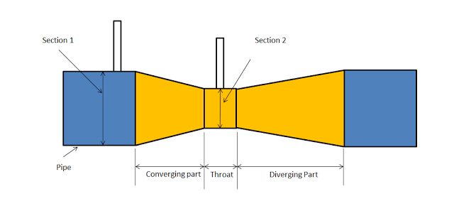](https://2.bp.blogspot.com/-J7_tqrtpRNM/V21M6IfXM7I/AAAAAAAAHGE/UOBRie5n7VoTK7LMo630gl-fiEz0jYSugCKgB/s1600/venturimeter.png)

### 1.3.2 Orifice Meter

An orifice meter is a thin plate with a chamfered edge to the hole in the middle of it which is placed into a long straight tube. Pressure tappings are made either side of the orifice plate and a manometer is connected between the two tappings. The pressure differential is a measure of the flow through the pipe.

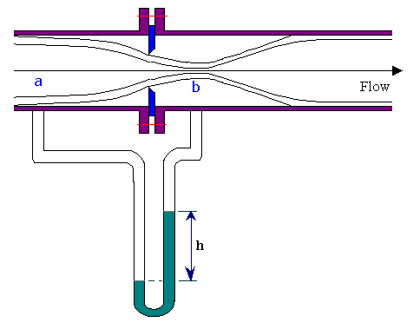

## 1.4 APPLICATION OF VENTURI METER AND ORIFICE METER

1. They are used to determine the fluid flow in tapering pipes.
2. They are used to produce pressure or increase the velocity of flow in small and large orifices.

## 1.5 Fluid to be considered: R134A (1,1,1,2-Tetrafluoroethane)

It is a hydrofluorocarbon (HFC) and haloalkane refrigerant with thermodynamic properties similar to R-12(dichlorodifluoromethane) but with insignificant ozone depletion potential and a somewhat lower global warming potential (1,430, compared to R-12's GWP of 10,900). It has the formula CH2FCF3, a density of **1295kg/m3** and a boiling point of −26.3 °C (−15.34 °F) at atmospheric pressure. R-134a cylinders are colored light blue.

### 1.5.1 PROPERTIES OF R134A

|  |  |  |
| --- | --- | --- |
| **No** | **Properties** | **R-134a** |
|  |  |  |
| 1 | Boiling Point | -14.9°F or -26.1°C |
| 2 | Auto-Ignition Temperature | 1418°F or 770°C |
| 3 | Ozone Depletion Level | 0 |
| 4 | Solubility In Water | 0.11% by weight at 77°F or 25°C |
| 5 | Critical Temperature | 252°F or 122°C |
| 6 | Cylinder Color Code | Light Blue |
| 7 | Global Warming Potential (GWP) | 1200 |

### 1.5.2 USES OF R134A (1,1,1,2-Tetrafluoroethane)

R134A is a non-flammable gas used primarily as a "high-temperature" refrigerant for domestic refrigeration and automobile air conditioners.. Other uses include plastic foam blowing, as a cleaning solvent, a propellant for the delivery of pharmaceuticals (e.g. bronchodilators), wine cork removers, gas dusters, such as Dust-Off, and in air driers for removing the moisture from compressed air. R134A has also been used to cool computers in some overclocking attempts. It is the refrigerant used in plumbing pipe freeze kits. It is also commonly used as a propellant for airsoft airguns.

# LITERATURE REVIEW

In engineering, the measurement of the flow rate of fluids is important in engineering because in some processes it is important to know that the fluid is in the right place at the right time. It is also important to measure fluid flow rate to ensure proper healthy and safe working conditi

A venturi meter or venturi flow meter is a device used to measure the velocity or flow rate of fluid flowing through a pipe. This device was discovered and named after an Italian Engineer Venturi, who used the venturi meter in his study of hydraulics of water flow in channels and pipes. He also noticed that the introduction of venturi meter in pipelines will allow the precise measurement of fluid velocity and flow rate. To measure the flow rate fluids in pipelines, the Bernoulli’s principle was applied to the venturi meter. The principle states that “an increase in speed of a fluid occurs simultaneously with a decrease in pressure or decrease in the fluid’s potential energy. Mathematically, this principle is represented as:

$\frac{P_{1}}{ρg}+\frac{V_{1}^{2}}{2g}+Z_{1}=\frac{P_{2}}{ρg}+\frac{V_{2}^{2}}{2g}+Z_{2}$…….. (i)

Where; $P_{1}$ =Pressure at inlet, $V_{1}$ =Inlet velocity, $P_{2}$ =Pressure at outlet, $V_{2}$ =Outlet velocity, $Z_{1}$ =Initial datum line, $Z_{2}$ =Final datum line, $ρ$ =Fluid density and $g$ =Gravitational constant (usually 9.81).

Furthermore, eqn (i) was worked upon to obtain the flow rate or discharge equation which is shown below:

Q= $C_{d}\frac{A_{1}A_{2}}{\sqrt{A_{1}^{2}-A_{2}^{2}}}\sqrt{2gh}$…….. (ii)

Where; $C_{d}$ = Co-efficient of discharge which varies between 0.96 and 0.98, $A_{1}$ = Cross sectional area of inlet, $A_{2}$ = Cross sectional area of outlet, $h$ = Differential head and $g$ = Gravitational constant (usually 9.81)

.

Note: Thus, we combines the **flow rate formula** (Q=AV), **Bernoulli equation** [in eqn (i)] and the **Torricelli theorem** (V= $\sqrt{2gh}$) to arrive at the relation in eqn (ii) which is known as the ***flow rate or discharge equation of pipelines.***

# METHODOLOGY OF ANALYSIS

## 3.1 Mathematical/Analytical solution of the given problem

**QUESTION TO BE SOLVED MATHEMATICALLY:**

A venturi meter is introduced in a 300mm diameter horizontal pipeline carrying water under a pressure of 150kN/m2. The throat diameter of the meter is 100mm and the pressure at the throat is 400mm of mercury below atmosphere. If 3% of the differential pressure is lost between the inlet diameter and the outlet throat, determine the flow rate in the pipe.

**Solution**

**Given:**

**d1 = Inlet diameter of the pipeline =** 300mm = 0.3m

**d2 = The throat diameter of the venturimeter =** 100mm = 0.1m

**P1 = Pressure at the inlet of the pipeline =** 150000N/m2

**Hfr = differential pressure head loss in percentage =** 3% = 0.03

**Vacuum pressure reading of mercury bow atmosphere =** -400mm = -0.4m

**Flow rate, Q =** ?

From the given parameters above, the following can be calculated;

**A1 = Inlet area of the pipeline = (**π/4)* d12 = 0.7854 * 0.32 = 0.0707m2

**A2 = Area of the throat of the venturimeter = (**π/4)* d22 = 0.7854 * 0.12 = 0.00785m2

**Let K = A1/A2 =** 0.0707 / 0.00785 = 9.00

**ϼ1 = Density of the fluid at the inlet of the pipe(R134A) =** 1295kg/m3

**ϼ2 = Density of the fluid at the throat of the venturimeter(mercury) =** 13600kg/m3

**SP1 = Specific gravity of water =** 1

**SP2 = Specific gravity of mercury =** 13.6

**g = acceleration due to gravity = 9.81m/s^2**

**h1 = differential pressure head at the inlet = (P1)/ (ϼ1*g) =** 15000/(1295*9.81) =11.8074 m of R134A

**h2 = differntial pressure head at the throat** = (mercury reading at the throat)*specific gravity of mercury

**h2 = -**0.4 * 13.6 = -5.44m of R134A

**h = total diferential pressure head = h1-h2 =** 11.8074 - (-5.44) = 17.2474m

**Hf = differential pressure head loss = Hfr * h =** 0.03 * 17.2474=0.5174m

With **Hf and h,** the value of the coefficient of discharge can be determined

**Coefficient of discharge, Cd is given by**

**Cd = (( h - Hf)/h) = (**17.2474– 0.5174**)/** 17.2474 = 0.9848858

**Lastly,**  the actual discharge or flow rate is given by

Q = Cd*A1 * 2*g*h K2 - 1

**Q =** 0.985 **\*** 0.0707 * 2*9.81*17.2474

**(**9.00**)2 –** 1 **Q =** 0.985 **\*** 0.0707 * 2.3569= 0.164m3/s

**Q = 164.0L/s**

# RESULTS AND DISCUSSION

## DISCUSSION

### Table and Graph of flow rate against the throat diameter

The flow rate was considered against varying values of throat diameter of 50mm, 75mm, 100mm, 125mm, 150mm and the data was gotten and presented in the table and graph as shown below :

|  |  |
| --- | --- |
| THROAT DIAMETER (m) | FLOW RATE, Q (L/s) |
| 0.050 | 40.9 |
| 0.075 | 92.`1 |
| 0.100 | 164.5 |
| 0.125 | 259.4 |
| 0.150 | 379.9 |

Fig. 4.1: Graph of throat diameter against flow rate

### 4.1.2. A Graphical User Interface (GUI) Python Code for validation of the analytical solution

z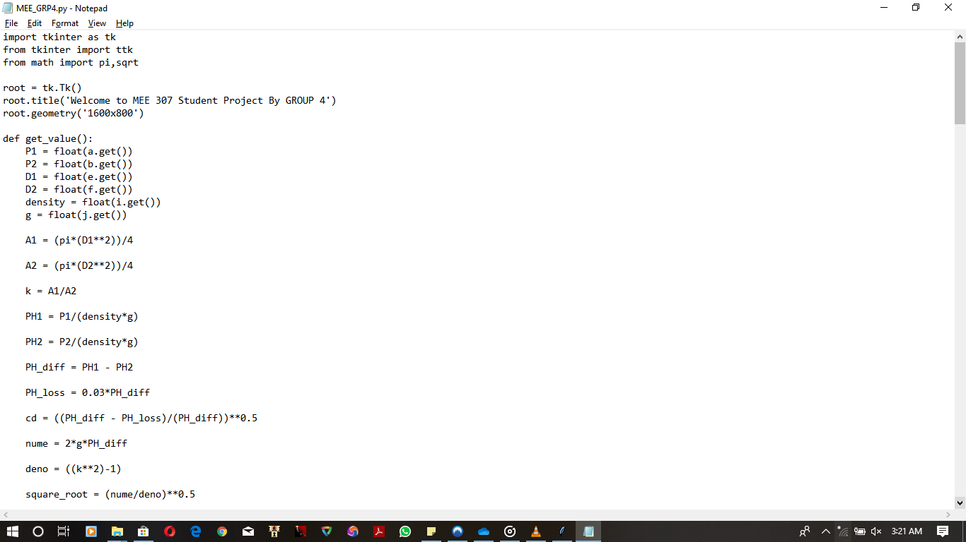

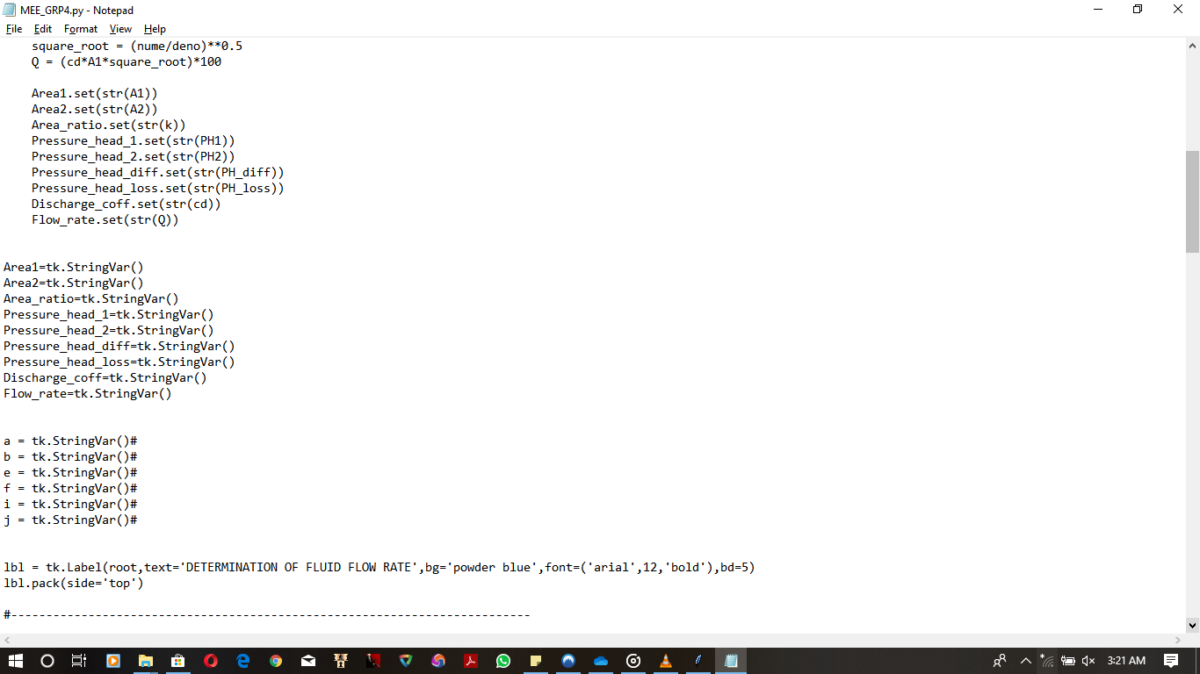

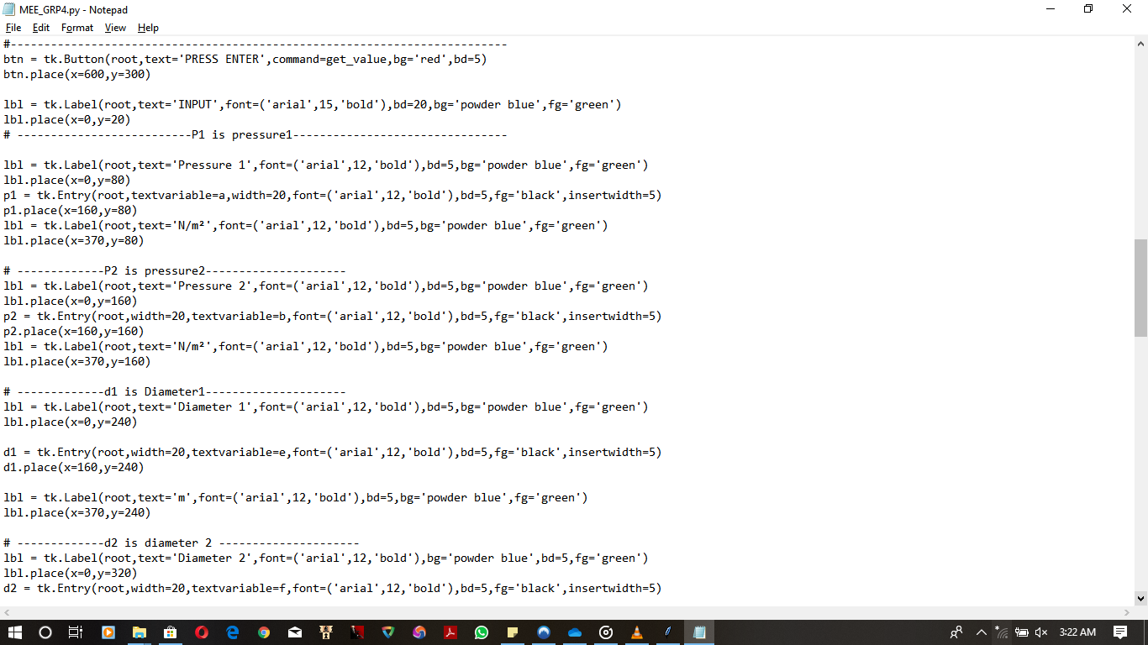

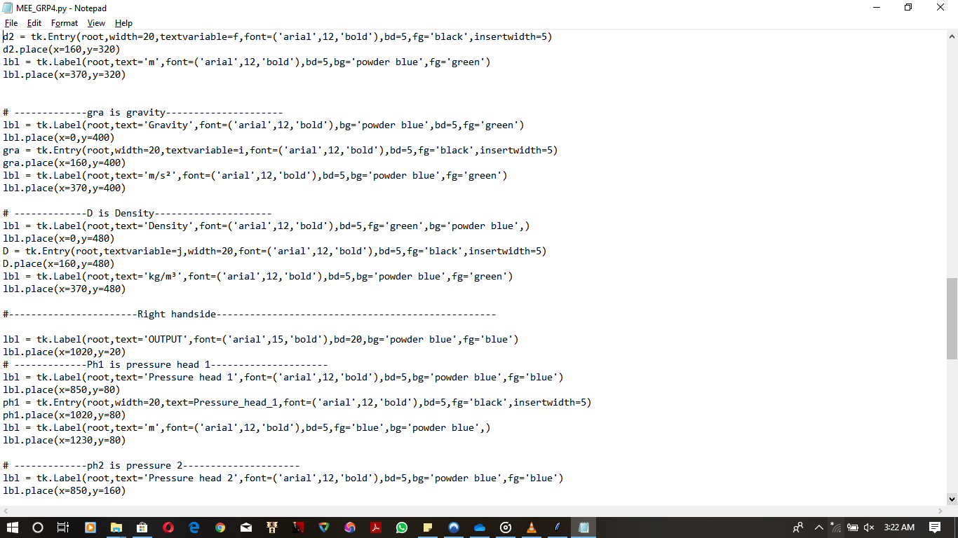

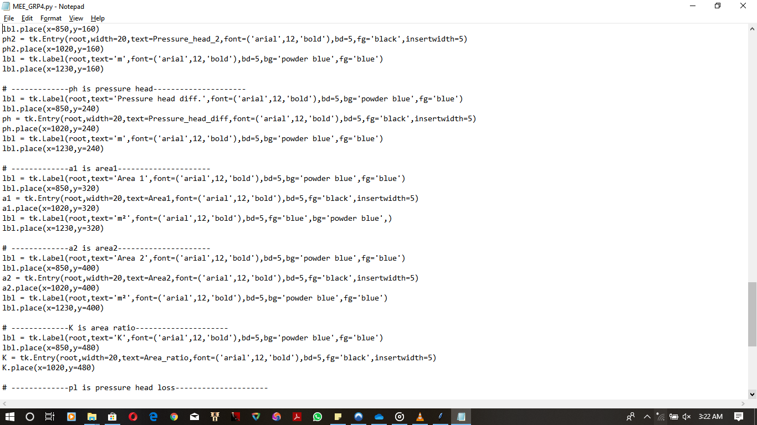

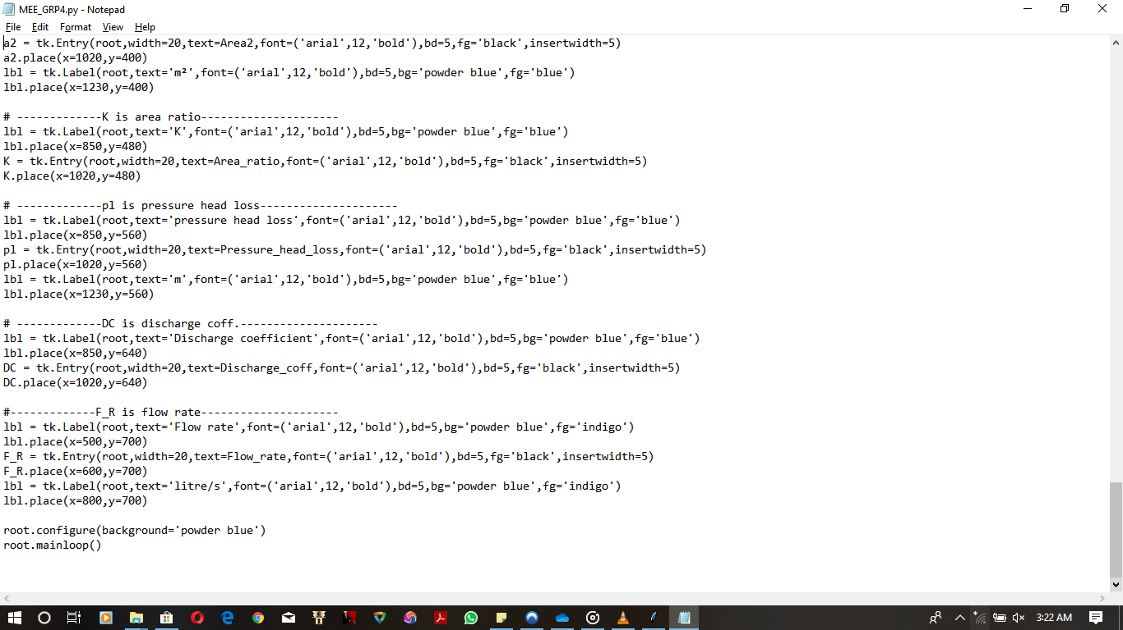

### Resut of calculation Program

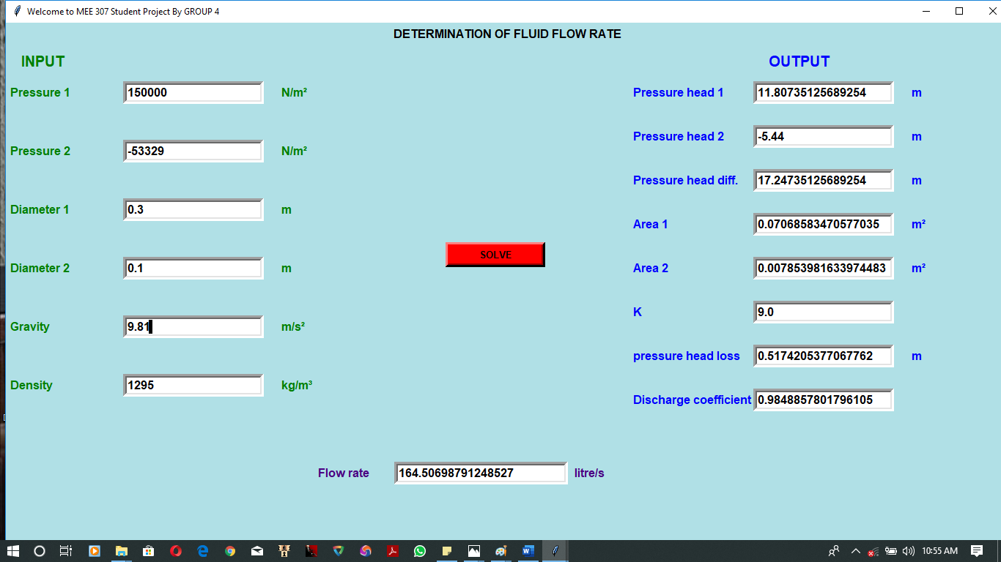

Fig.4.2: result of program calculation

### FLOWCHART OF PROGRAM

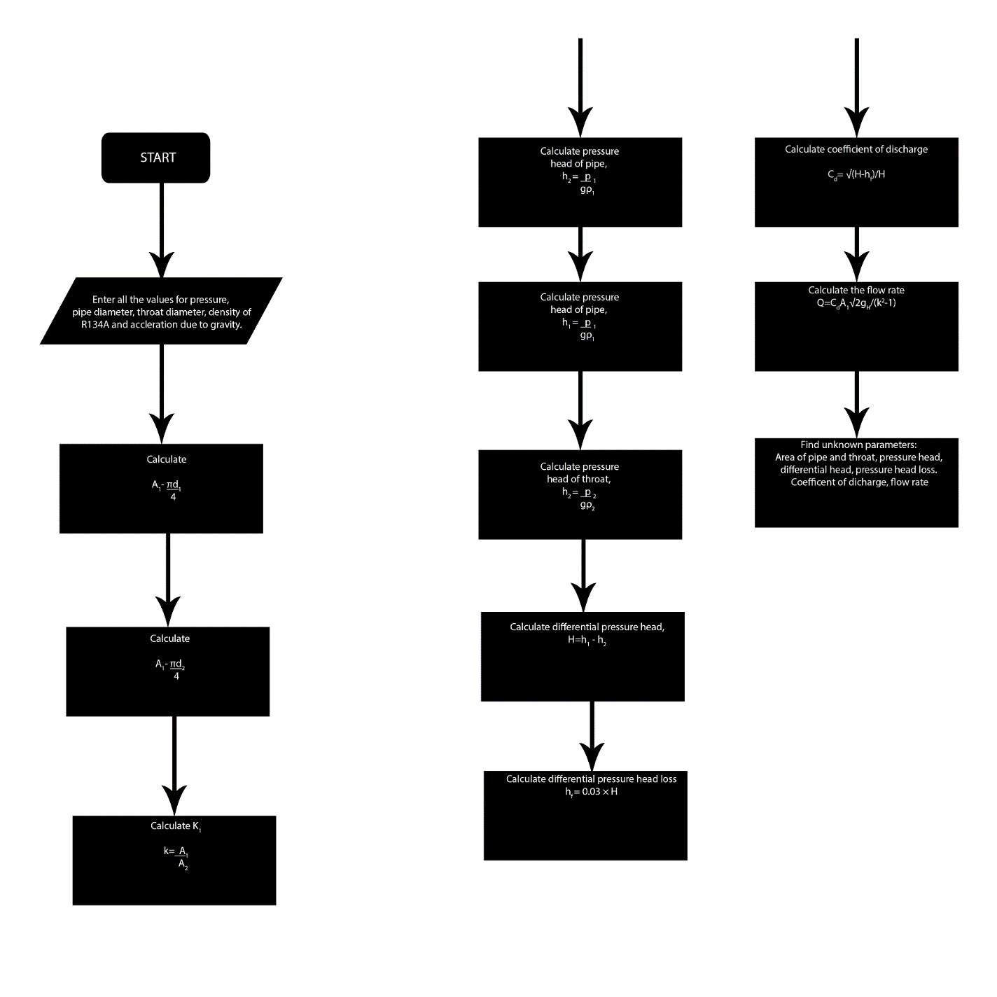

c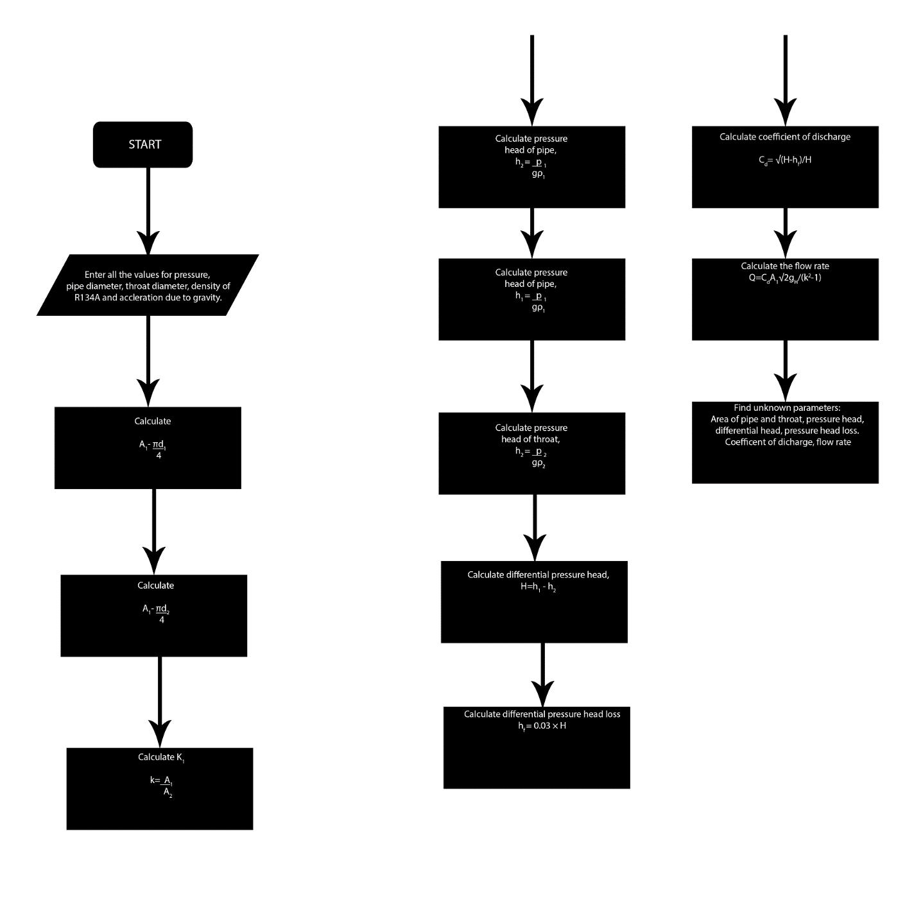



STOP

# CONCLUSION

The physical and numerical calculation presented in this work enabled us to draw a general conclusion and also suggest how we can control flow rate.

In conclusion:

1. It can be concluded that the flow rate of liquids can not only be derived or calculated on paper, but can also be simulated using computer programming language
2. A venturi meter is the instrument for finding flow measurement in pipelines. Using a discharge co-efficient, it is possible to find the mass flow rate in terms of upstream pressure.
3. The velocity of fluid in a pipeline and cross sectional area of pipelines are one of the strong factors that determines the flow rate of fluid in a pipeline. This agrees with the relation that, Q=AV.
4. Likewise, the introduction of venturi meter in a pipeline helps in the control of water hammer. This is because,even when there is a severe change in the velocity or pressure of fluid flowing in in pipeline, the venturi meter keeps the flow rate constant after some delay which will occur in the throat. Thus, any amount of fluid flow can be controlled using a venturi meter.

# REERENCES

Er. R.K. Rajput., (2011). Fluid Mechanics and Hydraulics: Practical Applications of Bernoulli equation; Venturi meter. India: New Delhi.

Apoloniusz Kodura, Katarzyna Weinerowska., (7th September, 2005). Water Management and Hydraulic Engineering: Some aspect of Water Hammer in Pipelines. Austria: Ottenstein.

Hojat Ghassemi, Hamidreza Farsi Fasih., (2011). Fluid Measurement and Instrumentation: Application of small size cavitating venturi as a flow controller and flow meter. Iran: Tehran: Iran University of Science and Technology.

Definition of venturi meter (n.d.). Retrieved from [www.wikipedia.com](http://www.wikipedia.com) on 24th june, 2019.

Definition of water hammer (n.d.). Retrieved from [www.wikipedia.com](http://www.wikipedia.com) on 24th june, 2019.

Dr. Collin Caprani., (2006). Fluid Mechanics 2nd Year Civil and Structural Engineering: Discharge of pipelines.